
City of Seagoville
702 N. Hwy 175 Seagoville, TX 75159
972-287-2050

GENERAL GUIDELINES FOR TEMPORARY FOOD ESTABLISHMENTS

Food means any raw, cooked, or processed edible substance; ice; beverages; or any ingredient; used or sold or intended for sale in whole or in part for human consumption, except tobacco or a drug as defined by the Texas Food, Drug and Cosmetic Act.

Temporary Food Service Establishment means a food products establishment that operates at a fixed location for a limited period of time in conjunction with a single event or celebration; or a concessionaire operating under a seasonal contract with either the Park and Recreation Department, Neighborhood Farmer’s Market, or the Seagoville Flea Market.

Risk Based permit processing:
High Risk- Extensive food preparation, serves a variety of food types.
Medium Risk- serves pre-cooked foods and less extensive preparation.
Low Risk- No cooking or preparation, serves or sells pre-packaged foods.

REQUIREMENTS FOR TEMPORARY FOOD ESTABLISHMENTS

- Permitting

  - An interview is needed to obtain a Temporary Event Food Service Permit. You will need to know all menu items, equipment to be used, dates, hours of food service operation and addresses of events. The interview and application will cover food source, preparation, handling, transportation, and temperature requirements. Additionally, booth structure, hand wash station, hand washing, bare hand control of ready-to-eat foods, sanitation, ware washing and wastewater disposal will be discussed. You must demonstrate adequate knowledge of food handling and sanitation practices in order for a permit to be issued.

  - The Temporary Event Food Service Permit will not be issued if a menu has not been determined, food sources are unapproved, the fee is not paid, or demonstration of knowledge is inadequate. You may reapply when conditions have been met. A temporary food service establishment must comply with the requirements of the current City of Seagoville Health Regulations for Temporary Food Service Establishments, except as otherwise provided in this regulation. The Department may impose additional requirements if needed to protect against health hazards.

  - Applications for, and issuance of Temporary Food Service Establishment Permits may be obtained at the above address. Permits are issued Monday through Friday between 8:00a.m. and 4:30p.m.

  - Applications must be received in this office at least five (5) working days prior to the event.
  - A non-refundable fee must be paid when the application is submitted. Vendors that will offer only prepackaged foods from the manufacturer that are non-time and temperature controlled and with minimum handling and preparation may request a limited-service food permit. Limited-service food permits require a nonrefundable permit fee for each facility from which the establishment is operated.

  - All vendors will need to submit a copy of their current local health permit and a copy of the last health inspection report conducted by the regulating authority. Vendors that do not have their own licensed kitchen will need to provide a permission letter from the owner of the kitchen where the food items will be prepared or stored.

  - Food Manufactures must submit a copy of the state manufacturer’s license along with the application.

  - Vendors must provide a copy of the invitation or letter from the event organizer granting permission to take part in the event.

  - Caterers located outside of the City of Seagoville, which provide food for public or private events must register with this department as an “Out-of-Town Caterer”. All caterers must be approved by the City of Seagoville and permitted by the appropriate regulatory authority.

  - Cottage Food Vendors must comply with current State and Local regulations.

- Food

  - Only foods which are pre-approved and require minimal handling will be considered. *No slicing, dicing or cutting of food products onsite (cooked hamburgers and fajitas may be sliced on the cooking surface). Temperature Controlled for Safety (TCS) food items will be limited to six items. TCS foods include meats, eggs, dairy products, rice, beans, potatoes, etc.

  - Seafood and poultry are only allowed under two conditions:
    - Raw product must be pre-cut, breaded and frozen, and go from the freezer to the deep fryer or
    - Product must be pre-cooked.

  - The only TCS food items allowed to be cooked on-site from a raw state are those which are fast cooking, such as:
    - Pre-formed hamburger patties
    - Beef fajitas
    - Sausages, hotdogs, etc.

  - All other TCS items must be prepared and cooked at a permitted food facility that is inspected regularly. All cooked food products must be properly transported to the temporary site while maintaining proper temperatures.

*EXCEPTIONS WILL BE REVIEWED BY MANAGEMENT ON A CASE BY CASE BASIS

- Structure

  - All temporary food establishments are required to have approved flooring, which may include concrete, asphalt, or tight-fitting plywood.

  - All stands must have a suitable overhead covering for food preparation, cooking, utensil washing and serving areas. Covering must meet Seagoville Fire Code requirements. A table skirt or other form of protection is recommended to protect food, single service articles and utensils.

  - All grills must have overhead covering while in use.

  - Fire extinguishers must be present if using equipment with open flames. If propane is used during the event a fire permit is required. Propane tanks for grills or other pressurized tanks, such as those used for fountain soft drinks, must be secured so they cannot fall and damage valves.

  - Booths must have barriers to protect food and prevent customers from entering into the booth.

- Sink Requirements

  - Temporary food establishments that operate for 96 hours or less and do not have conveniently available hot and cold running water and sanitary sewage facilities MUST FURNISH THE FOLLOWING FACILITIES,
when food items are not pre-packaged.

  - Hand washing facilities, which are conveniently located are required for all establishments which handle food. Must provide FLOWING WATER to be used for hand washing and a collection basin (bucket) for wastewater. Must set up hand wash facilities BEFORE setting up booth and preparing food. Coffee urns, drink coolers, or bottled water with a spigot are examples of what is required. At least a five (5) gallon potable water capacity should be available. Soap and paper towels must also be available.

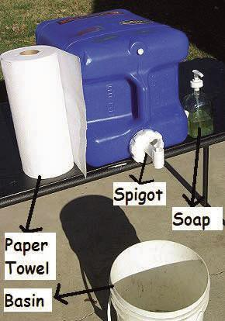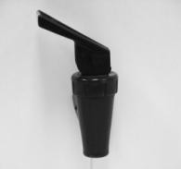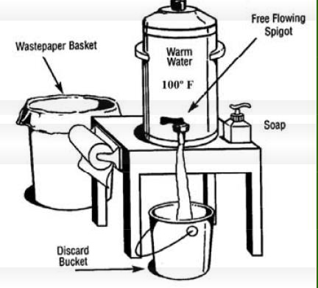
Spigot

  - Utensil Washing and Sanitization

A container with soapy water solution is required for the washing of dirty utensils on site. This is for emergency use only.

A sanitizer solution container must be provided to sanitize clean utensils and equipment. The required residual of 50-100ppm chlorine may be obtained by placing one (1) tablespoon of regular household bleach in one (1) gallon of water for the sanitizer. Other approved sanitizers may be used. Test papers must be provided to ensure that proper sanitizer concentration is achieved. All utensils must be taken to a commissary location daily to be properly washed, rinsed and sanitized.

  - All wastewater from sinks, steam tables, buckets, etc. must be disposed of into a sanitary sewer system or in a manner that is consistent with the Liquid Waste Disposal Code Requirements.

  - All wiping cloths must be stored, between uses, in an approved sanitizer solution at the proper concentration. If chlorine is used as the sanitizer, a solution of one hundred (100) parts per million is required. Chemical test strips for the approved sanitizer being used must be maintained on site to ensure the proper concentration of the sanitizer.

  - Those establishments which operate more than 96 hours or 4 days or more and serve food products other than pre-packaged items MUST PROVIDE HOT AND COLD RUNNING WATER sufficient for employee hand washing and for the cleaning and sanitizing of utensils and equipment.
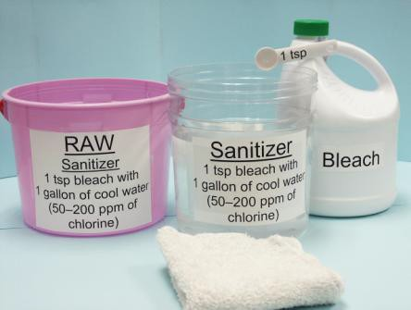

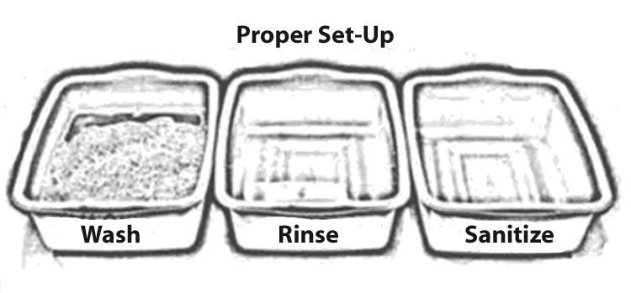

- Food Protection and Handling

  - All TCS foods requiring refrigeration must be stored at a temperature not to exceed 41°F or colder. TCS foods which are required to be held hot, must maintain a temperature of 135°F or hotter to prevent bacterial growth. Mechanical holding units are required in each booth to ensure that proper temperature is maintained. Canned heat (sterno) is not allowed for maintaining hot food temperatures outside. Ice chests are not allowed for maintaining cold food temperatures. A metal stem thermometer must be provided where necessary to check the internal temperatures of hot and cold foods. Thermometers must be accurate to + 2° F.

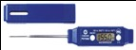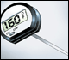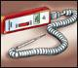

  - Open and unprotected displays of food are not allowed. When using chafing dishes, only hinged-lid types will be allowed so that at least half of the food remains covered at all times.

  - READY-TO-EAT (RTE) FOOD CAN NOT BE TOUCHED WITH BARE
HANDS. A barrier must be provided between the bare hand and the ready-to-eat food. Examples of physical barriers include: gloves, deli tissues, tongs, ladles, spatulas, forks, etc.

  - Food handlers must not have infected cuts, lesions, or open wounds. Food handlers with upper respiratory symptoms such as constant coughing or sneezing or food handlers with gastrointestinal symptoms such as cramps, vomiting and diarrhea must be restricted from handling food.

  - All condiments, including onions, relish, sauces, peppers, catsup, mustard, etc., that is available for customer use must be in self-service packets or be dispensed from approved sanitary dispensers.

  - All foods, food containers, utensils, napkins, straws and single service articles must be stored at least 6” off the floor and adequately protected from splash, dust, insects, weather or other contamination sources.

  - When self-service ice dispensers are not provided, ice scoops are required. Ice used for human consumption must be stored separately from ice used to refrigerate drink bottles, cans or cartons. Ice storage units must be drained to a wastewater receptacle or a sanitary sewer system to prevent submergence of beverage containers into melted ice.

  - Effective hair restraints, including hairnets and caps are required
in food preparation and serving areas. Food, beverage and tobacco consumption is prohibited inside food booths. Gum chewing is also prohibited in food preparation and serving areas.

- Food handling personnel must wash their hands as frequently as necessary to keep them clean, even though disposable gloves may be used. Nails must be closely trimmed and maintained. No sculptured nails or chipped nail polish is allowed.

- Animals are prohibited from being within fifty (50) feet of a temporary food establishment or food service area.

Temporary event food service requires special consideration and planning of structures, transport, hygiene and food safety to safeguard public health. It is the intent of this guideline to assist food vendors to operate in compliance with regulations, provide food that is safe to consumers, and prevent the spread of foodborne illness.
For more complete information, please refer to the current version of the Texas Food Establishment Rules.

Temporary Food Establishment permits are issued “in person” or “by mail” (not by phone or electronically), so you will have the opportunity to discuss any questions. Before applying for a permit, please decide on the following:
  - The complete menu including beverages.
  - The booth structure (whether provided by the event sponsor or the vendor).
  - The equipment that will be required, including a hand washing method.
  - Methods to maintain hot and cold product temperatures.
  - How all foods will be transported and stored.
  - Where and how clean up of equipment will be done.
  - Identification of the person who will be in charge of the booth.

Failure to comply with these regulations may result in the closure of the food establishment, revocation of the permit and/or municipal court citations. Food unfit for human consumption may be reconditioned, impounded, destroyed or denatured.

